Lesson 1 Interactive

Identify the different parts of the basic ProgeCAD interface.

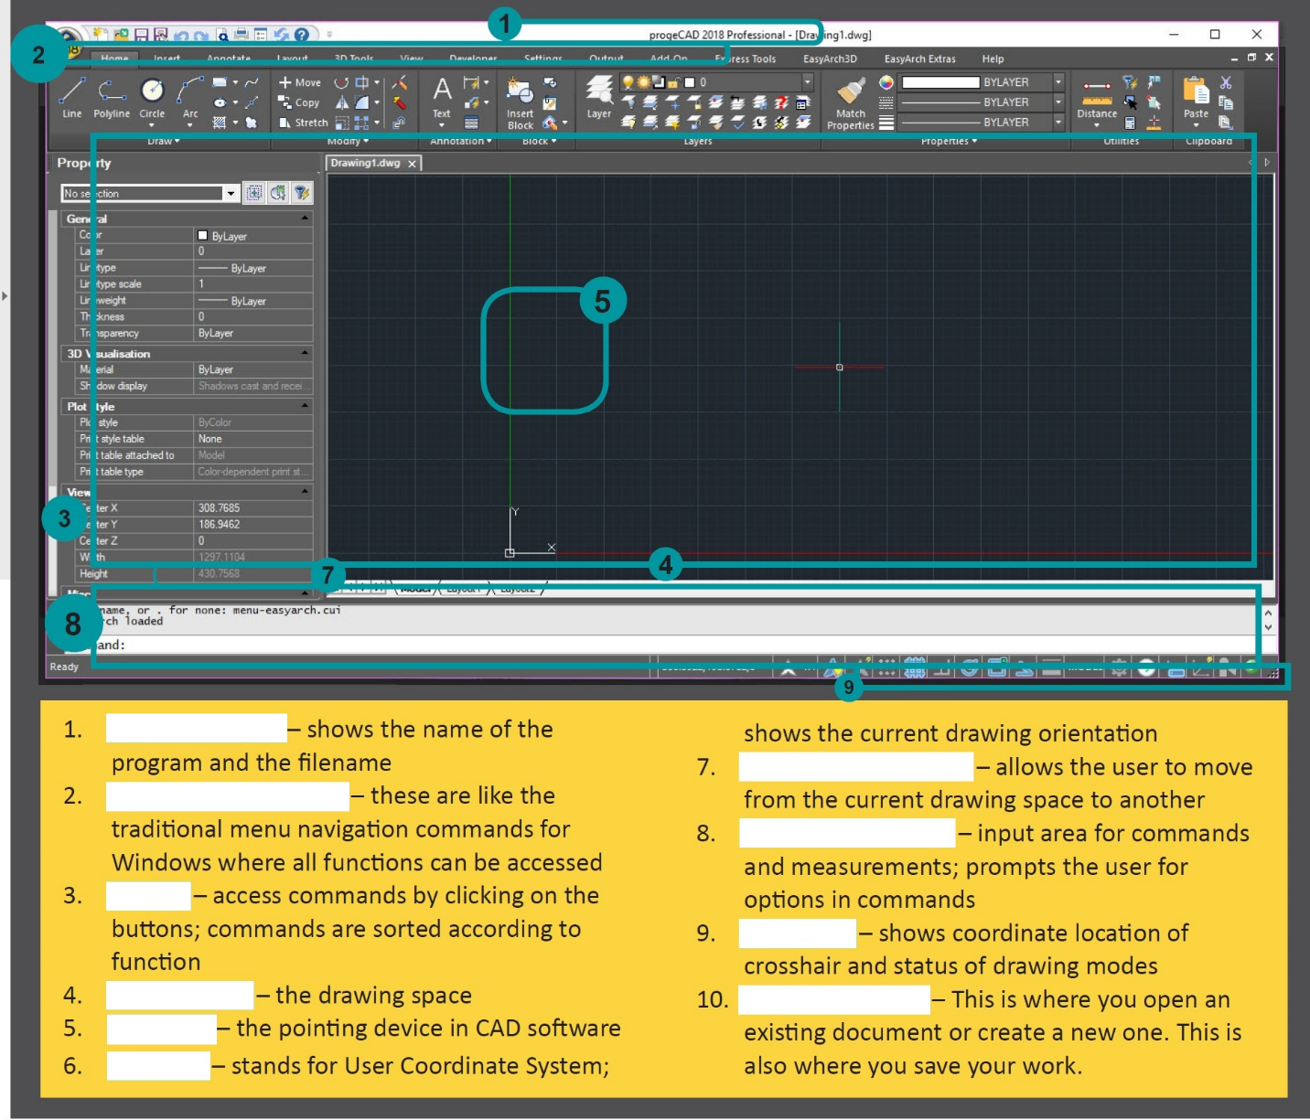

Save as the file using this filename: Lesson 1 – (your surname).docx

